MED D - Researching and Submitting Paper Claims

High Level Process
Researching Paper Claim Inquiries
Submitting Paper Claims
Additional Paper Claim Requirements
Beneficiary Disputes or Questions Reimbursement Amount on Rx
Checks and Explanation of Benefits (EOB)
Prescription Drug Claim Form (Standard)
Paper Claim Viewer in PeopleSafe
Dismissal of Paper Claim
Turn Around Times (TAT) - Paper Claim
Related Documents

Description: This document provides the process for submitting a paper claim for reimbursement and then researching paper claim inquiries. The paper claim processing system provides a traditional paper claims reimbursement method for instances where a beneficiary must use out-of-network retail pharmacies, when circumstances require they pay full price at an in-network pharmacy, or when they pay out of pocket at a doctor’s office, or for outpatient stays in a hospital.

High Level Process
- Determine if the beneficiary has already submitted a paper claim.  - If yes, research the paper claim. Proceed to Step 2.  - If no, run test claims for the date of service to verify coverage and then proceed to the Submitting Paper Claims section.  - If beneficiary is returning a call regarding a previously submitted paper claim, then review comments and advise accordingly.  Note: The beneficiary can request a reimbursement three ways. Refer to the following for the requirements for each option.  - A completed Paper Claim Form  - Online through Desktop/Mobile Site or Mobile App  - Without a Paper Claim form | Note: The Paper Claims Processing system is integrated with the Point of Sale (POS) and Mail system to ensure that only covered drugs are reimbursed and that claims do not receive duplicate payment. The Paper Claims system ensures that claims will only be reimbursed for members eligible at the fill date of the prescription.  Foreign claims or prescriptions dispensed by a physician’s office are not reimbursable by Med D.
- Locate the claim in question.  - If found, proceed to Step 3.  - If not found, ask the caller when the claim was submitted and refer to the Turn Around Times (TAT) for Paper Claims section of this document to determine if enough time has elapsed for the reimbursement to be mailed. | If beneficary received a Dismissal Notice, refer to Dismissal of Paper Claim.
- Determine if the claim is “Paid” or “Rejected”.  - If paid, review the detailed breakdown of how the paper claim paid and advise the beneficiary accordingly, then proceed to Step 5.  - If rejected, proceed to Step 4. | The total amount will not always be reimbursed back to the beneficiary.  The PBM is unable to change the amount to a covered amount. If the beneficiary disagrees with the reimbursement amount, refer to Beneficiary Disputes Reimbursement Amount on Rx.
- Determine and advise the beneficiary of the reason for rejection and discuss any available options to resolve the issue.
- If additional information is required to process the claim, the beneficiary will need to resubmit the claim paperwork with the missing information
- If claim was process incorrectly, proceed accordingly.
- If the beneficiary disagrees with the reimbursement amount, proceed to Beneficiary Disputes Reimbursement Amount on Rx.
- Address any other member issues.
- If the beneficiary requests a copy of the claim documents, send email to ClaimPullRequests@CVSHealth.com.
- If the beneficiary states they have submitted their paper claims multiple times and do not understand the reason(s) for denial, transfer to the Senior Team for assistance.

Top of the Document

Researching Paper Claim Inquiries

Perform the following steps:
Step | Action
1 | Determine if the beneficiary has already submitted a paper claim.  - If yes, research the paper claim. Proceed to Step 2.  - If no, run test claims for the date of service to verify coverage and then proceed to the Submitting Paper Claims section.  Note: If beneficiary is returning a call regarding a previously submitted paper claim, then access the Paper Claim Viewer in PeopleSafe to review all paper claims that have been received and processed:  - If the beneficiary would like to be transferred to the paper claim representative, ask the beneficiary to provide the number and warm transfer the call to the paper claim representative.  - If the beneficiary would like to provide the CCR the information, an RM Task can be submitted.  Submit the following RM task:  Task Category: Paper Claims  Task Type: Participant Research Request (CRR)  Queue: Paper Claims-SCT-RxClaim-Participant  Notes: Explain the reason for the call (verifying a call made by paper claims) and note any specific beneficiary requests or information provided by the beneficiary.  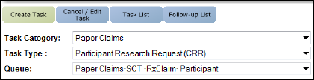  Return to High Level Process
2 | Locate the claim in question on the Main Screen in PeopleSafe using the Rx Number, Dispensed Drug name, and Filled date.  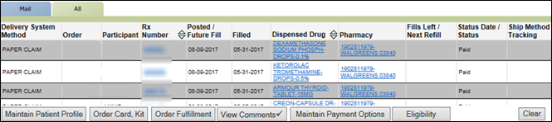  Note: The Delivery System Method will be PAPER CLAIM.  Return to High Level Process
2 | If the claim is... | Then...
2 | Found | - Click the Rx Number link.  - Result: The Prescription Details screen will display.  - Proceed to Step 3.
2 | NOT Found | Ask the caller when the claim was submitted and refer to the Turn Around Times (TAT) for Paper Claims section of this document to determine if enough time has elapsed for the reimbursement to be mailed.
2 | NOT Found | If... |  |  |  | Then...
2 | NOT Found | Enough time (30-45 days) has elapsed since the claim was submitted |  |  |  | View comments at the member level to determine if the letter has been received.  - If yes, advise the caller that it has been received and that the packet has been rejected because it was missing information. Research the cause of the packet rejection in Paper Claim Viewer in PeopleSafe and advise the caller to resubmit with the appropriate information. Refer to MED D - Paper Claim - Reject Reason Codes.  - If no, verify the correct paper claims address and ask the caller to resubmit. Refer to Turn Around Times (TAT) - Paper Claim.  Note: Paper Claims are not noted by the Claims department.  Note: If beneficiary has resubmitted multiple times without resolution, follow standard escalation procedures.
2 | NOT Found | Beneficiary has not allowed enough processing time (30-45 days) |  |  |  | - Remind the caller that our processing time begins once we receive the claim.  - Advise them of the approximate date of receipt and the various options available for checking the status of the claim (callback, web).
2 | NOT Found | Beneficiary states they received a Dismissal Notice |  |  |  | Proceed to Dismissal of Paper Claim.
3 | Determine if the claim was “Paid” or “Rejected” by reviewing the Status field on the Prescription Details screen.  Note: The number in Claim / Sequence field will match the number on the Prescription Claim Reimbursement Statement (PCRS) sent to the member.  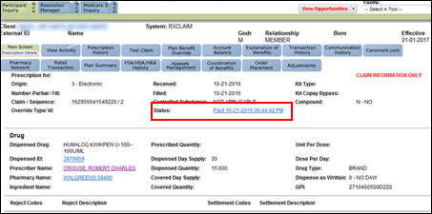  Return to High Level Process
3 | If the claim is … |  | Then...
3 | Paid |  | - Click the View Financials button.  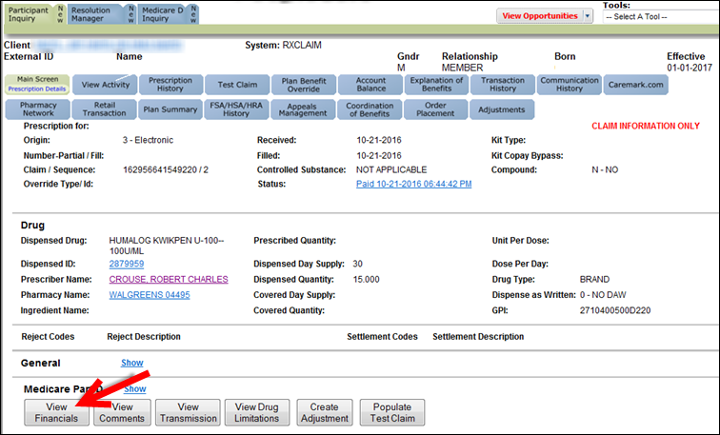  - Review the Financial Details screen along with the Explanations of Benefit screen for a detailed breakdown of how a paper claim paid and advise beneficiary accordingly.  - The total amount will not always be reimbursed back to the beneficiary. The local pharmacy is allowed to charge what is called a “usual and customary” (U&C) amount for the drug dispensed. If a beneficiary fails to use their prescription benefits card, the pharmacy will not be able to determine the contracted amount between the PBM and the pharmacy. This means that the amount is not covered and is shown in the Total Excluded field.  - The reimbursement check information will be in the Participant Reimbursement and Recipient sections at the bottom of the screen. CCRs can determine when a reimbursement check was issued and to whom it has been addressed.  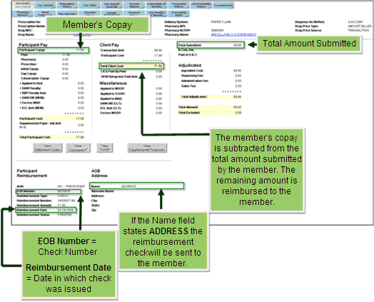  - Proceed to Step 5.  The PBM is unable to change the amount to a covered amount. If the beneficiary disagrees with the reimbursement amount, refer to Beneficiary Disputes Reimbursement Amount on Rx.
3 | Rejected |  | Proceed to the next step.
4 | Determine and advise the beneficiary of the reason for rejection and discuss any available options to resolve the issue.  - Review the Settlement Code and Settlement Description fields on the Prescription Details screen. Refer to MED D - Paper Claim - Reject Reason Codes.  Note: When a paper claim is denied, the beneficiary will not receive the original paperwork back. The paperwork is scanned into the system and the beneficiary will receive a copy of the scanned image.  Return to High Level Process
4 | If… |  |  |  | Then…
4 | Additional information is required to process the claim |  |  |  | - The beneficiary will need to resubmit the paperwork with the missing information.  - Inform the caller that our processing time will begin once we receive the resubmitted claim.  Note: Refer to the Turn Around Times (TAT) for Paper Claims section of this document for more information.
4 | Claim was processed incorrectly |  |  |  | Research the cause of the packet rejection in Paper Claim Viewer in PeopleSafe and advise the caller to resubmit with the appropriate information.
4 | If the beneficiary disagrees with the reimbursement amount |  |  |  | Refer to Beneficiary Disputes Reimbursement Amount on Rx.
5 | Address any other beneficiary questions.  Return to High Level Process
5 | If... |  |  | Then...
5 | A copy of the claim documents is being requested |  |  | Send an email to ClaimPullRequests@CVSHealth.com.  In the email, include the following:  - Member name  - Member ID  - Prescription numbers in question and the fill dates  - Claim/Document #
5 | Beneficiary states they have submitted their paper claims multiple times and do not understand the reason(s) for denial |  |  | Transfer to the Senior Team. The senior team can verify the turnaround time.  Provide the senior resolution team beneficiary the following information:  - Member ID  - Member Name  - Date of Service  - Client Code  - Name of medication(s)  Refer to MED D - When to Transfer Calls to the Senior Team and Basic Call Handling.

Top of the Document

Submitting Paper Claims

Perform the steps below:
Step | Action
1 | Advise the beneficiary to complete one of the below options in order to request a reimbursement:  Notes:  - Claim forms are provided to all beneficiaries to complete and submit along with their prescription receipts for reimbursement per the plan design benefit.  - Some Medicare D plans (with an AOB provision) allow the beneficiaries to assign their benefits to a pharmacy, provider, facility, or other individual (power of attorney, spouse, etc.) in lieu of receiving the reimbursement themselves. A MED D - Appointment of Representative (AOR) form or Power of Attorney (POA) document should be submitted with the Paper Claim.  - If the beneficiary is deceased, a paper claim can still be submitted. If completing the Prescription Drug Claim Form, the beneficiary signature is not required. A Med D Appointment of Representative (AOR) form or Power of Attorney (POA), however will be required.  - If the beneficiary asks the CCR to submit the paper claim form on their behalf, advise them in order to file the paper claim specific information will be needed that only they can provide. (Example: Detailed pharmacy prescription receipt)
1 | Submit… | Requirements…
1 | A Paper Claim Form | - Obtain the Prescription Drug Claim Form.  - Submit the following information:  - A completed Prescription Drug Claim Form  - If the beneficiary is assigning benefits to another party:  - The name and address of the assignee.  - Write “AOB” below the Member Information Section.  - A detailed pharmacy prescription receipt along with any discount card that was used and the amount of the discount.  - A detailed pharmacy prescription receipt includes the following information:  - Rx Number  - NPI/NCPDP Number  - NDC Number  - Metric Qty/Days Supply Number  - DAW (if applicable)  - Dispensed Quantity  - DEA/NPI Number  - Date of Fill  - Cost of Medication  Notes:  - If the days’ supply is not listed on the receipt from the pharmacy, tell the plan beneficiary to contact his/her local pharmacy or pharmacist to ask for the information. Tell the plan beneficiary to either:  - Ask the local pharmacy to print a new receipt that includes the days’ supply;  - Ask the local pharmacy to print a report that includes the days’ supply information; or handwrite the days’ supply on the original receipt.  - Claims that do not include the days’ supply will be returned to the plan beneficiary with a letter explaining how to obtain the days’ supply from the pharmacy. The days supply is necessary to ensure appropriate benefits consideration. Once the days’ supply has been obtained, the plan beneficiary should resubmit the claim form, a copy of the letter and the receipt(s) back to the PBM at the appropriate post office box.  - Proceed to the next step.
1 | Online through Desktop/Mobile Site or Mobile App | Refer to Caremark.com – Submitting Paper Claims Through Desktop/Mobile Site or Mobile App (Medicare D).  Note: Only Select MED D clients can submit paper claims using the online tool.
1 | Without a Paper Claim form | If the beneficiary cannot access a Prescription Drug Claim Form or does not have access to a computer/mobile device, they can:  - Provide the following required information on a blank piece of paper:  - Primary Member ID#  - Member Name (and DOB or ID# if different from cardholder)  - Member Address  - Submit the following information:  - The required information on a blank piece of paper  - A detailed pharmacy prescription receipt along with any discount card that was used and the amount of the discount.  - A detailed pharmacy prescription receipt includes the following information:  - Rx Number  - NPI/NCPDP Number  - NDC Number  - Metric Qty/Days Supply Number  - DAW (if applicable)  - Dispensed Quantity  - DEA/NPI Number  - Date of Fill  - Cost of Medication  Notes:  - If the days’ supply is not listed on the receipt from the pharmacy, tell the plan beneficiary to contact his/her local pharmacy or pharmacist to ask for the information. Tell the plan beneficiary to either:  - Ask the local pharmacy to print a new receipt that includes the days’ supply;  - Ask the local pharmacy to print a report that includes the days’ supply information; or handwrite the days’ supply on the original receipt.  - Claims that do not include the days’ supply will be returned to the plan beneficiary with a letter explaining how to obtain the days’ supply from the pharmacy. The days supply is necessary to ensure appropriate benefits consideration. Once the days’ supply has been obtained, the plan beneficiary should resubmit the claim form, a copy of the letter and the receipt(s) back to the PBM at the appropriate post office box.  - Proceed to the next step.
1 | Additional Notes:  - MED D Paper Claims have a 90 day electronic (at POS) and a 3 year (manual claim form) filing limit.  - Payments should not be sent to the Paper Claims mailbox.  - Some plans may have these benefits set up under a commercial secondary plan for their beneficiaries.  - If the beneficiary used more than one pharmacy, each pharmacy will need to be submitted separately.
2 | Advise the beneficiary some claim types also have Additional Paper Claim requirements.  Notes:  - Foreign claims or prescriptions dispensed by a physician’s office are not reimbursable by Med D.  - Some vaccines received in a physician’s office may be eligible for reimbursement.  - Proof of payment for vaccines administered in a prescriber/clinic setting, and the amount of any administration fee corresponding to the vaccine.
3 | Provide the beneficiary with the address where they should submit their Paper Claim documents. Check the Client Information Form (CIF) for paper claims addresses. If no specific address is listed, use the general address:  P.O. Box 52066  Phoenix, AZ 85072-2066  Note: Ensure that all submitted documents are clear and legible.
4 | Advise the beneficiary that their submitted claim will be adjudicated and processed according to the client’s specific plan design and they will receive a Prescription Claim Reimbursement Statement (PCRS).  - If the claim is approved for payment, a reimbursement check for the prescription amount less the appropriate co-payment will be included with the statement.  - If payment is denied, the PCRS will indicate the reason for denial and a notice of denial will be mailed with appropriate appeal information.  Note: If a claim receives a Manual Reject Letter (MRL), no PCRS will be generated. The Notice of Denial will explain the reason for the denial.
5 | Set beneficiary expectations by providing them with the information in the Turn Around Times (TAT) for Paper Claims section.

Top of the Document

Additional Paper Claim Requirements
To submit a Paper Claim, members should complete a Prescription Drug Claim Form and provide a detailed pharmacy prescription receipt (refer to the Submitting Paper Claims section above). Some claim types also have additional Paper Claim requirements. Refer to the table below for those requirements.

- Multi-Ingredient Compound Prescription Claims
- Coordination of Benefits (COB) Claims
- Overpayments/Alternate Insurance Paid in Error
- Nursing Home Claims

Paper Claim Type | Other Requirements
Multi-Ingredient Compound Prescription Claims | For Multi-ingredient compound, two forms will be needed:  - MED D standard paper claim form - provides the beneficiary information.  - Compound prescription form - includes all of the ingredients listed separately, with metric quantity and cost for each.  - This form should be filled out by the pharmacy to ensure accuracy.  To request a compound prescription form, the CCR will submit the following RM Task:  - Task Category: Fulfillment  - Task Type: Claim Forms  - Queue: Fulfillment - Richardson  - Notes: Specify that a compound prescription form is needed.  Note: When the CCR requests the form for a compound prescription, a MED D standard claim form will be mailed in addition to this form. The beneficiary will automatically get both with the one request. The CCR does not need to submit two separate requests.  Each ingredient used to make up the compound must be listed separately and noted on the Claim Form. In addition, totals must match the pharmacy prescription receipt.
Coordination of Benefits (COB) Claims | In order to take advantage of the COB benefit, the client’s plan design must have coordination of benefits and paper claims provisions.  - Review the Client Information Form (CIF) in theSource.  - Advise the beneficiary that they must submit a standard MED D Claim form and at least one of the following:  - Pharmacy receipts indicating other insurance  - Explanation of Benefits from the Primary Insurer  - Statement of cost from the primary insurer  - Computer generated cost summary from the provider of service which shows the total paid or amount covered/not covered by the Primary Insurer.  - Confirm with the beneficiary that the documentation they will submit with the MED D Claim form contains the following information:  - Fill Date  - NCPDP/NPI number  - RX number  - NDC number  - Quantity/Days Supply  - Total Paid amount  - Copay amount  - Primary Paid  - Member name  - Member information, member name and DOB or/and ID
Overpayments/Alternate Insurance Paid in Error | Changes in eligibility/plan benefits may result in claims processing after their coverage effective dates. As a result, the beneficiary may receive a collection letter requesting repayment for claim paid after coverage termination. The beneficiary would then submit to Caremark for manual processing.  - Advise the beneficiary that they must submit a standard MED D Claim form and at least one of the following:  - Pharmacy receipts indicating other insurance  - Letter requesting repayment for claim paid after coverage termination  - Statement of cost from the previous insurer  - Computer generated cost summary from the provider of service which shows total paid or amount covered/not covered and the copay amount the beneficiary paid with other insurance  - Confirm with the member that the documentation they will submit with the MED D Claim form contains the following information:  - Fill Date  - NCPDP/NPI number  - RX number  - NDC number  - Quantity/Days Supply  - Total Paid amount  - Copay amount  - Primary Paid  - Member name  - Member information, member name and DOB or/and ID
Nursing Home Claims | Nursing Home claims are accepted under the Med D Benefit. They must be received within 90 days from the date of service to be processed to the facility for reimbursement.  Documentation must include the following:  - Fill Date  - Rx number  - 11 digit NDC  - Drug Name  - Quantity  - Days Supply  - Amount Paid  - Subscriber information  - Beneficiary name and ID  The fact that the beneficiary resides in a nursing home must be checked off or annotated on the claim form. Nursing Home plan design provisions generally do not have restricted days supply’s etc.  Note: In order to assign benefits the plan member must indicate this on the submitted claim.

Top of the Document

Beneficiary Disputes or Questions Reimbursement Amount on Rx

Perform the steps below:
Step | Action
1 | Ask the beneficiary which medication they are calling about and confirm the copay amount paid.
2 | Determine if the beneficiary:
2 | If... | Then...
2 | Paid full price at a retail pharmacy and didn’t show ID card at pharmacy  Note: MED D claims must be within 90 days of the date of fill. | CCR will educate the beneficiary on the following:  - Beneficiary must return to filling pharmacy, present ID card, and request to have the claim reversed and resubmitted for the correct co-pay amount.  CCR Process Note: CCR should make an outbound call to the pharmacy to provide processing info if the beneficiary does not have their ID card or if the beneficiary presented it, but the claim is still not found on their profile.  Note: If pharmacy needs assistance, CCR can provide the following contact the number to the Retail Services (Retail Help Desk) - MED D: 1- 866-693-4620. If pharmacy will not/cannot reprocess, CCR will send paper claim form to beneficiary.  Refer to MED D - Standard Claim Form - 193491_Claim Form 15071-MED_D-0912.
2 | Paid full price at a retail pharmacy and has SPAP coverage, but didn’t show SPAP card | Refer to MED D - Handling State Pharmaceutical Assistance Program Calls.
2 | Is enrolled in a plan with a Preferred Pharmacy Network but went to a standard pharmacy instead of a Preferred Pharmacy | - CCR will educate the beneficiary that they must use a preferred pharmacy in order to receive the lower copay.  - Access the CIF for information regarding the Plan’s Preferred Pharmacy Network and provide the beneficiary information regarding participating pharmacies.
2 | Plan made an error in calculating beneficiary TrOOP, which caused the beneficiary to pay the incorrect coverage cost share | Paper claims scenarios are considered Coverage Determinations – refer to the following:  - MED D - CCR - Coverage Determinations and Redeterminations (Appeals)
2 | None of the above are true | Proceed to step 3.
3 | - Access the beneficiary’s claim on the View Financial screen in PeopleSafe to determine the copay amount.  - Access the Plan Design section of the CIF and review the copay amount listed in the Copay Matrix.  - Determine if the copay amounts listed in PeopleSafe and the CIF match:
3 | If... | Then...
3 | The amounts listed in PeopleSafe and the CIF match | CCR will advise the beneficiary the amount was correct and educate the beneficiary regarding their plan design.  - If the beneficiary expresses dissatisfaction about the amount, alternative medications should be offered. If beneficiary declines alternatives, a Tier Exception should be offered, as appropriate.  - Refer to:  - MED D - Grievance vs. Coverage Determination - Decision Matrix  - MED D - Coverage Determinations and Redeterminations (Appeals)  - If beneficiary expresses dissatisfaction, a grievance should be offered, as appropriate.  - Refer to MED D - Grievances Index.  CCR Process Note: If the beneficiary states they cannot afford their medication refer to the following work instructions:  - For Tiering Exceptions, refer to MED D - Coverage Determinations and Redeterminations (Appeals).  - For help paying for all medications, refer to:  - MED D - Low Income Subsidy (LIS) Informational Overview  - Prescription Financial Assistance for Members
3 | The amounts listed in PeopleSafe and the CIF do NOT match and CCR is unable to find a reason for copay discrepancy  Note: This scenario is subject to 14-day Turn Around Time | Review the CIF to determine if we handle paper claims for the client.
3 |  | If... | Then...
3 |  | No | Follow process outlined in the CIF.
3 |  | Yes | Ask the beneficiary if they have picked up and paid for the medication.  - If no, continue research to identify copay discrepancy including reaching out to Senior Team or Supervisor for assistance if needed.  - If yes, run a test claim.  - If the claim adjudicates correctly then the CCR should call the Pharmacy and ask them to reverse and reprocess the claim.  - If the test claim does not adjudicate correctly or if the Pharmacy is unable to reverse and reprocess, then CCR to proceed to the next bullet point for direction on how the beneficiary can request a refund.  To request a refund, you must submit a reimbursement request in writing (Paper Claims). A check for any amount due will be issued within 14 days from the day the PBM receives your request in writing.  Refer to the following sections of the document for submission requirements:  - Prescription Drug Claim Form (Standard)  - Submitting Paper Claims
3 | The beneficiary requests to appeal the amount reimbursed | Determine if the beneficiary has submitted a paper claim:
3 | The beneficiary requests to appeal the amount reimbursed | If... | Then...
3 | The beneficiary requests to appeal the amount reimbursed | Yes | Advise the beneficiary a decision letter will be mailed within 14 days. If reimbursement is due, it will be mailed within 30 days.  Submit the following RM Task:  Task Category: Paper Claims  Task Type: Participant Research Request (CRR)  Queue: Paper Claims-SCT-RxClaim-Participant  Notes: Explain the reason the beneficiary is disputing the amount reimbursed on their claim and note any specific beneficiary requests or information provided by the beneficiary.
3 | The beneficiary requests to appeal the amount reimbursed | No | To request a refund, you must submit a reimbursement request in writing (Paper Claims). A check for any amount due will be issued within 14 days from the day the PBM receives your request in writing.  Refer to the following sections of the document for submission requirements:  - Prescription Drug Claim Form (Standard)  - Submitting Paper Claims

Top of the Document

Checks and Explanation of Benefits (EOB)
The Explanation of Benefits screen provides the CCR with the list of claims processed in each reimbursement, the financial cost breakdown, drug information and the address of where the reimbursement check was sent.

Refer to MED D - Explanation of Benefits (EOB)

Perform the steps below:
Step | Action
1 | Click on the Explanation of Benefits navigational tab (PeopleSafe Main Screen).
2 | Review information contained on screen to include:  - EOB can be the Check Number; it depends on the platform.  - Addressing Information  - Financial Breakdown Information  - Rx Details  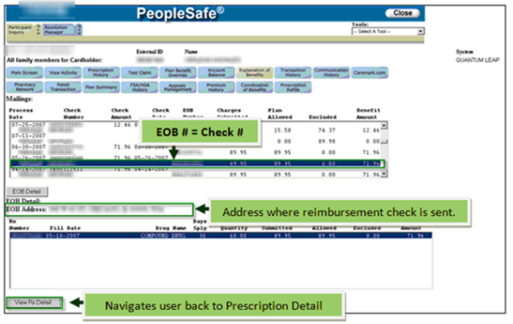  Figure B
2 | If… | Then…
2 | Beneficiaries name and address are listed | Beneficiary will be receiving a check.
2 | No name is listed | Pharmacy will receive the check.
2 | Claim is paid but there is no check/payment information | Contact the Senior Team and provide the following:  - Prescription Number  - Medication Name  - Date of Fill  - Pharmacy NCPDP/NPI  Note: The Senior team will to take over the call and work with the Claims department to issue the stop payment and reissue or void and reprocess.  Refer to MED D - When to Transfer Calls to the Senior Team and Basic Call Handling.
3 | The explanation of benefits and checks are within 2 business days.  - If the beneficiary states they have lost the check, refer to the Stop Payment procedures.

Top of the Document

Prescription Drug Claim Form (Standard)
Refer to the image of a MED D Standard Paper Claim form:

MED D - Standard Claim Form - 193491_Claim Form 15071-MED_D-0912

Beneficiaries can obtain claim forms via the following methods:
Platform / Task | Navigational Path
Customer Care  IVR | - More Choices  - Order Forms  - Claim Form
Aetna Website  (Recommended Method) | - For members  - Get a form  - Claims & Reimbursements  - Print a prescription drug claim form  Note: Login NOT required.
Caremark.com | - Plan & Benefits  - Print Plan Forms  - Paper Claim Reimbursement Form  Refer to Caremark.com - Make a Reimbursement Claim.  Note: Login required.
Customer Care - PeopleSafe / Fulfillment Automation | - Main Screen  - Order fulfillment button  Refer to MED D - Fulfillment Request.  Note: Turnaround Time is up to 10 business days to receive the requested item.
Customer Care - PeopleSafe Resolution Manager Task | Check the CIF first to confirm that the plan allows paper claims before sending the RM Task.  Resolution Manager Tab  Task Category: Fulfillment  Task Type: Claim Forms  Queue: Fulfillment - Richardson  Task notes must include the following: “Unable to place the request through the Order Fulfillment button”.  Notes:  - This task should only be used if the order fulfillment button is not allowing the CCR to place the request.  - Turnaround Time is up to 10 business days to receive the requested item.

Top of the Document

Paper Claim Viewer in PeopleSafe
MedForce is a system used by the Paper Claims Department to scan paper claims received from our beneficiaries. Onshore CCRs can now access MedForce via the Paper Claim Viewer in PeopleSafe and should not reach out to the Senior Team.

Note: Offshore CCRs will not have access to Paper Claim Viewer. If additional research is needed, the Offshore CCR will transfer the call to the Senior Team.

The Paper Claim Viewer is read only and can be used to:
- Confirm if beneficiary’s paper claims were received and/or processed.
- Determine if there was a discrepancy with the paper claim image received vs. how it was processed.

Step | Action
1 | While on the Participant Inquiry Screen, navigate to the Tools menu, chose Paper Claim Viewer.  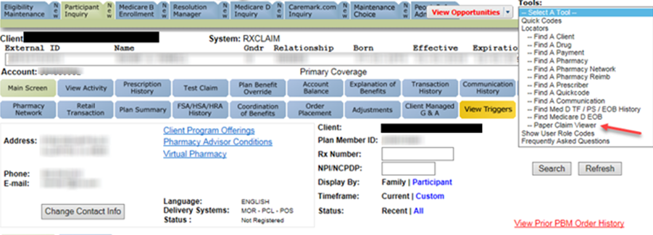  Result: Popup window for MEDFORCE will appear with the beneficiary’s information auto populated.  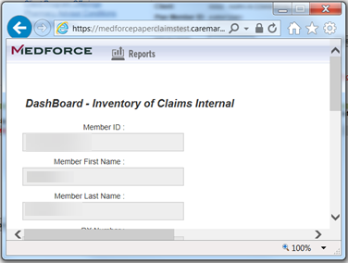
2 | Right click on the top bar of the screen and click on Maximize in the menu that appears.  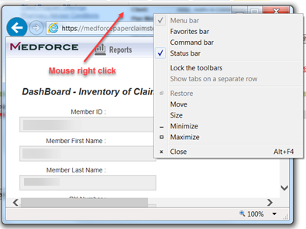  Result: Any Paper Claims the member has submitted will appear at the bottom of the screen.  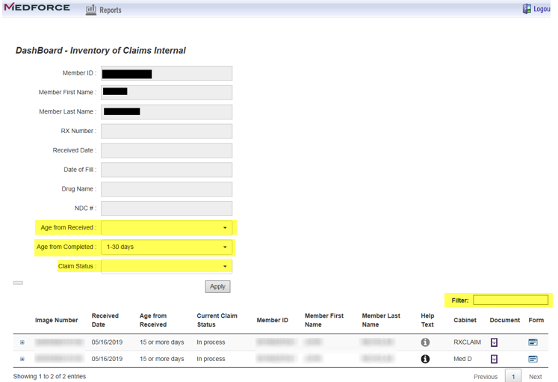  Note: These results can be narrowed down by selecting the Age From Received (from the date the claim was received), Age from Completed (from the date the claim was processed), or Claim Status drop down options. Users may also enter the full or partial Image Number within the Filter box.
3 | Locate the Paper Claim in question and click the Filing Cabinet button in the Document column.  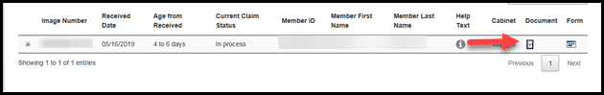  Result: The selected Paper Claim Image will display. Use the navigation buttons to move through the pages of the claim as needed.  Navigates to the first page of the claim.  Navigates one page back.  Navigates one page forward.  Navigates to the last page of the claim.  Note: Click on Outgoing Letter to view letters.  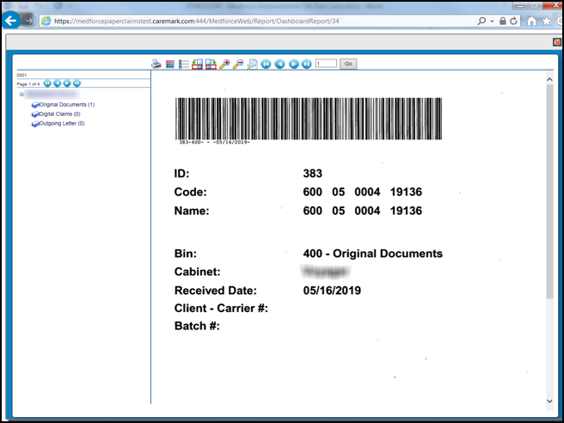

Top of the Document

Dismissal of Paper Claim

Perform the steps below:
Step | Action
1 | View the Dismissal Notice in Paper Claim Viewer in PeopleSafe to determine the reason for the dismissal.
2 | Advise the beneficiary on the reason the case was dismissed, including what specific information was missing.
3 | Determine the reason the beneficiary is calling:
3 | If calling to... | Then...
3 | Submit required documentation | Advise the beneficiary to resubmit ALL required documentation within 60 days of the date of the dismissal notice if they would like to appeal or within 180 days to vacate the dismissal. Vacating involves rescinding the original decision to dismiss and processing the claims, if all the information needed to process the claim is provided. The beneficiary will receive a vacate letter if this is the case.  Note: Any documentation received outside of the 60-day timeframe (BUT within 180 days) will be reviewed as a new Coverage Determination.
3 | Appeal Dismissal | - Refer to the CIF for client’s specific appeals process.  - Advise the beneficiary to resubmit ALL required documentation for processing.
3 | Appeal Dismissal | If... | Then...
3 | Appeal Dismissal | All documentation is submitted | The request will be reviewed again for reimbursement. The beneficiary will receive an approval to vacate letter.
3 | Appeal Dismissal | Any documentation is missing | The request will be denied and the beneficiary will receive a denial notice.  Note: If the appeal was denied, direct the beneficiary to the Independent Review Entity for additional processing and determination.

Top of the Document

Turn Around Times (TAT) - Paper Claim
Turnaround time is based on CMS guidelines.
- Paper Claims are processed within 14 calendar days, if submitted for the first time.
- If an Appeal is received, the decision will be mailed to the beneficiary within 14 calendar days, and payment within 30 calendar days, if payment is due.

If claims are… | Then…
Eligible | Documentation will display in the system.
Not Eligible | No documentation will display in the system.
Processed | Beneficiary will receive either a reimbursement check or a Prescription Claim Reimbursement Statement (PCRS) within 14 calendar days of receipt of initial request.

Top of the Document

Related Documents
- Grievance Standard Verbiage (for use in Discussion with Beneficiary) section in MED D - Grievances Index
- MED D - CMS Criteria for Using out of Network Pharmacies
- MED D - Paper Claim - Reject Reason Codes

Parent SOP:
- CALL-0048: Medicare Part D Customer Care Call Center Requirements-CVS Caremark Part D Services, L.L.C.
- CALL-0011: Authenticating Caller
Abbreviations/Definitions: Abbreviations / Definitions

Top of the Document

Not To Be Reproduced Or Disclosed to Others Without Prior Written Approval
ELECTRONIC DATA = OFFICIAL VERSION – PAPER COPY = INFORMATIONAL ONLY

